**Name: Aqsa Khurram**

**SAP ID: 50086**

**Operating System Lab**

**Task 01**

**Creating**

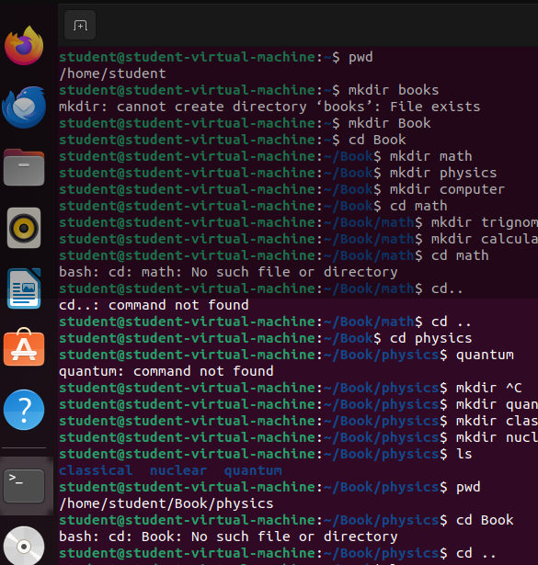

**Output:**

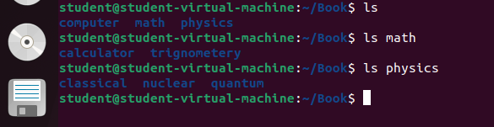

**Creating Chemistry and going to home**

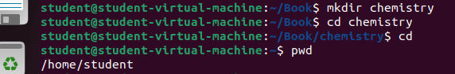

**Task 02**

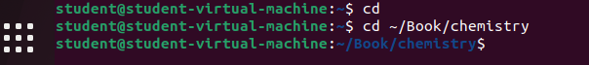

**It’s a relative Path**

**Task 03**

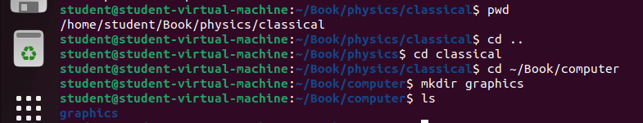

**Task 04**

